Q) Can Computer kill human? Illustrate with two examples.

Ans:

Figure below is a Boeyng 777 plance crash on the runways due to the failure in the computer system of the airplane. The main reason for the crash was that the computer did not respont to the command initiated by the pilot and had problem in take off.

**So yes computer can kill human.**

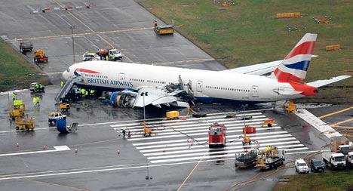

Figure below is taken from a science fiction movie : Transformer Salvation. The robot which was meant to serve humans were hacked and instructed to kill the human beings.

Though this is a world of fiction and is director’s imagination but today’s computer scientist are thinking of robots which could be in humans’ service and many robots are built also.

But every development has pros and cons if the robots are not secured we could even imagine such dark day to become areality.

**So yes computer can kill human**

